Executing parallel logical operations with DNA
Mitsunori Ogihara, and Animesh Ray
In Proceeding of the IEEE Congress on Evolutionary , pp. 972-979, 1999
Abstract
DNA computation investigate the potential of DNA as a massively parallel computing device. Several proposals have been made in this direction. We overview those methods, discuss technical and theoretical issues involved, and present some possible applications of those methods.

Introduction
- Evaluating Semi-Unbounded-Fan-In Circuits
(Others：unbounded-Fan-In Circuits, bounded-Fan-In Circuits)
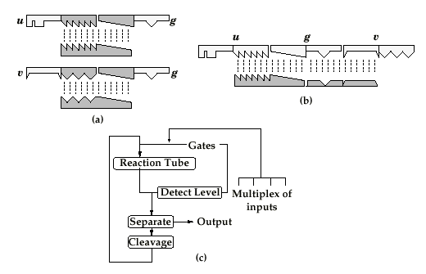

2、Self-propagating circuit simulation with Primer-Extension
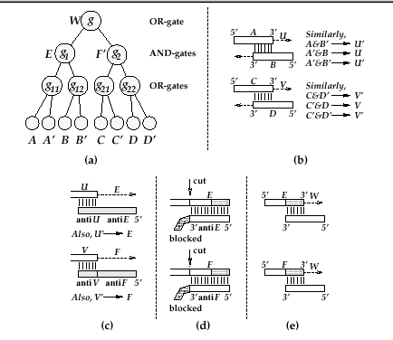
3、Primer-Extension
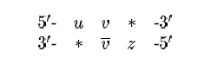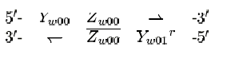

Created by : Hung-Yuan Wang
Date : Oct. 16, 2001

